**LAB QUIZ #2 (Static Website)**

**Requirements:** (Requirements needed to complete the lab activity e.g. software, application)

* HTML
* CSS
* JavaScript
* Git

**Groupmates:** Bagtas, Gwyn Clyd S.

**Laboratory Problem (Provide with Screenshots)**

1. Create a website with git as your version control system. Minimum of 5 web pages. Submit your website in zip file with link using the OneDrive attached in your documentation. The documentation should be submitted in your assignment.

Show the progress of your website using the git and list the content of your git log.

↓

Day 1 - I created the 4th and 5th page named “SUPPORT’ and “ABOUT”

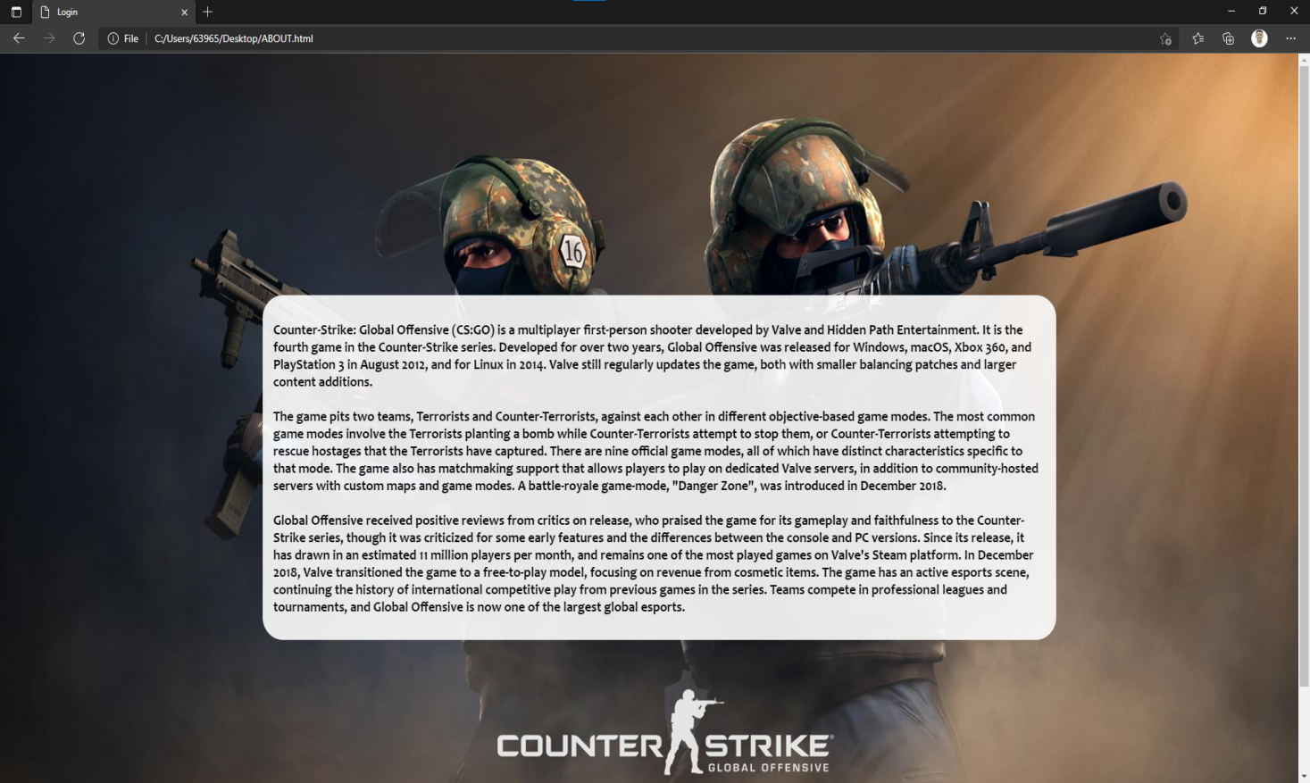

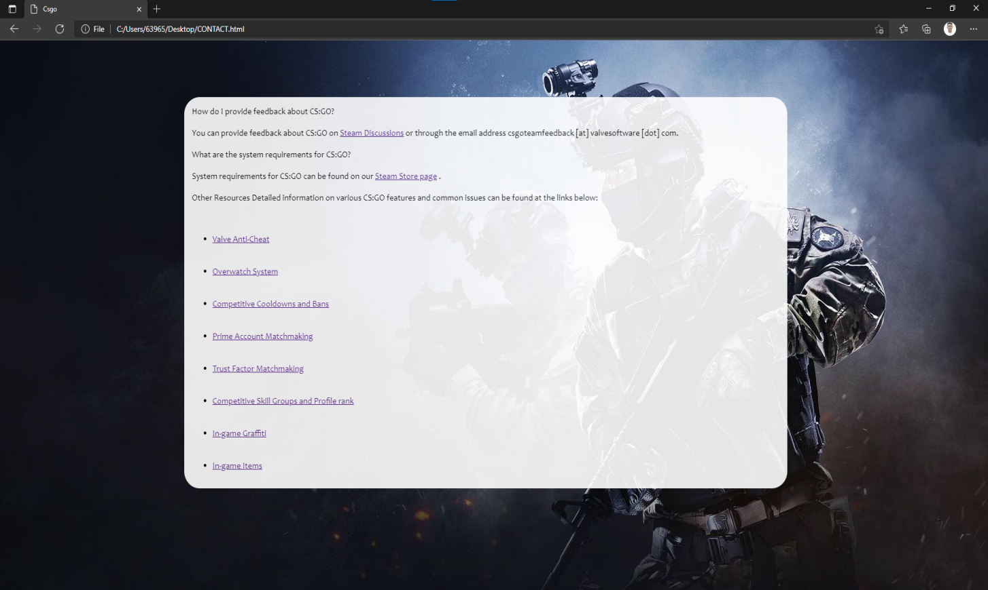

Day 2 - Second i have created my landing page to create the five pages



Day 3 - I created the first page “REGISTER”

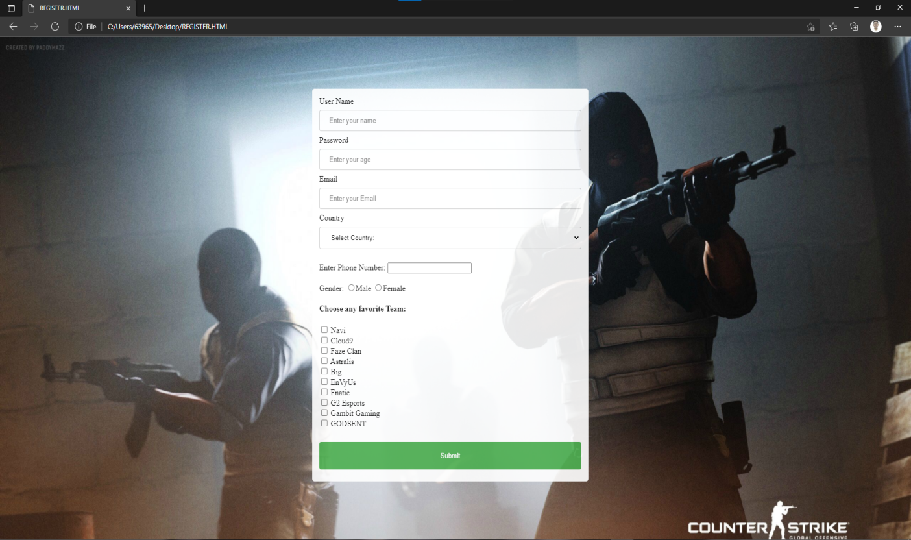

Day 4 - I created the second page “LOGIN”

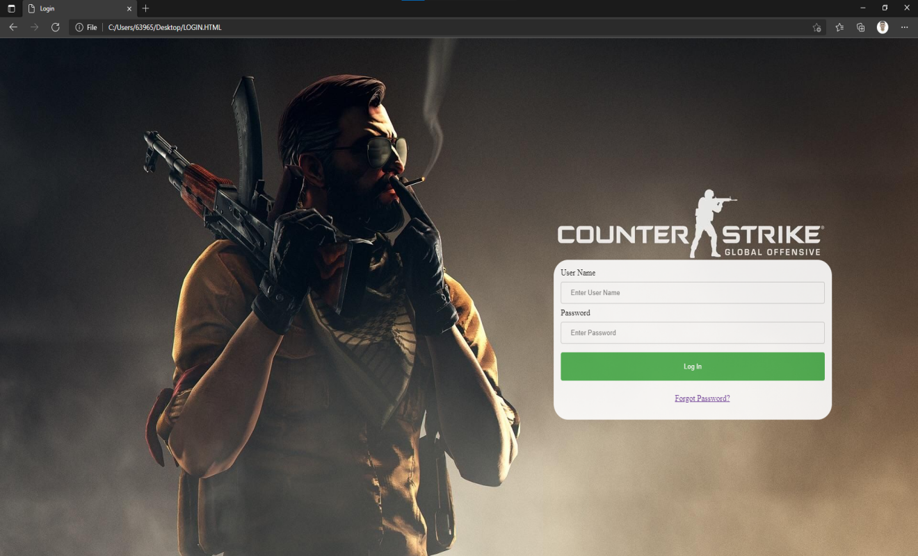

Day 5 - I created the third page “CS:GO TOURNAMENTS”



DAY 1 - GIT LOG

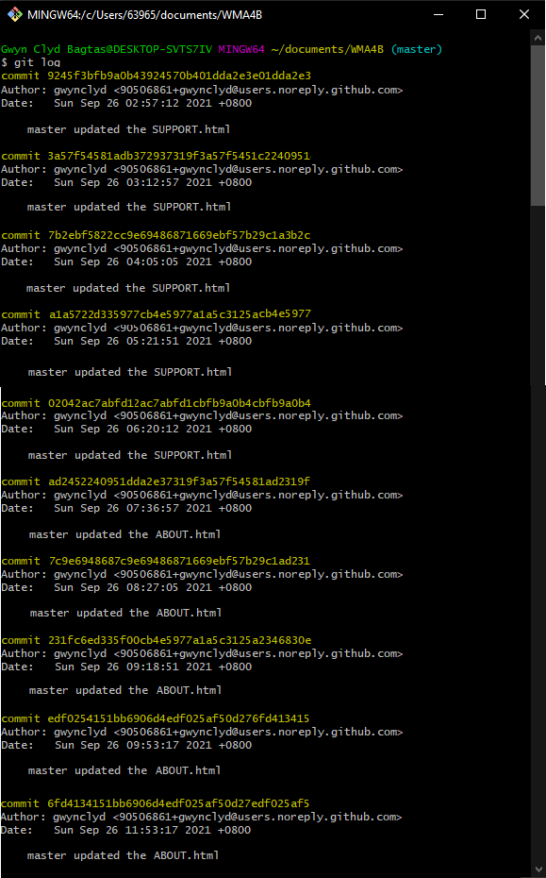

DAY 2 - GIT LOG

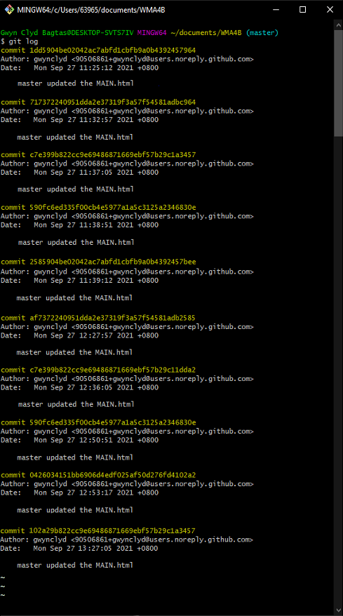

DAY 3 - GIT LOG

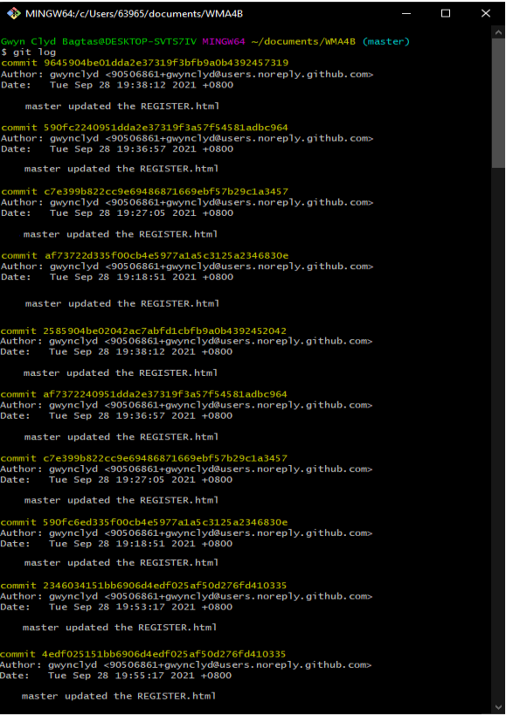

Day 4 - GIT LOG

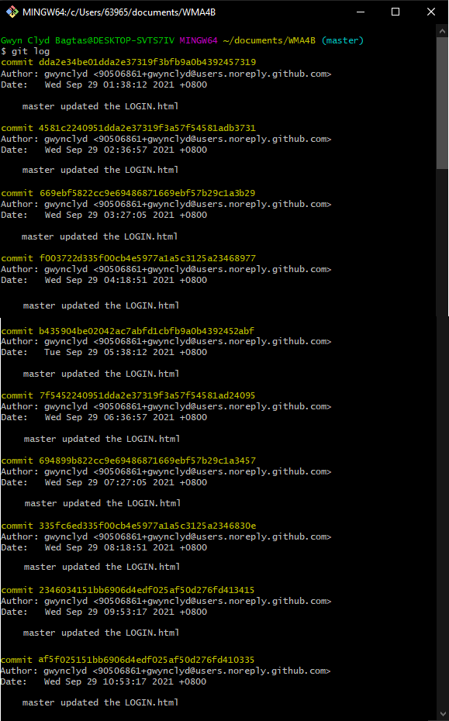

Day 5 - GIT LOG

